Contents

A - ASP.NET Core Fundamentals 2

Page rout Razor 2

Action result 2

# A - ASP.NET Core Fundamentals

## Page rout Razor

* Query string

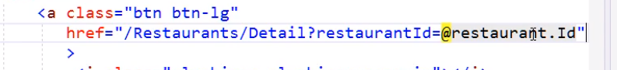

* Asp tag helper

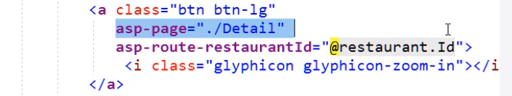

* Page Route

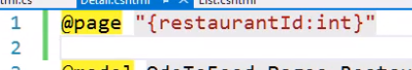

## Action result

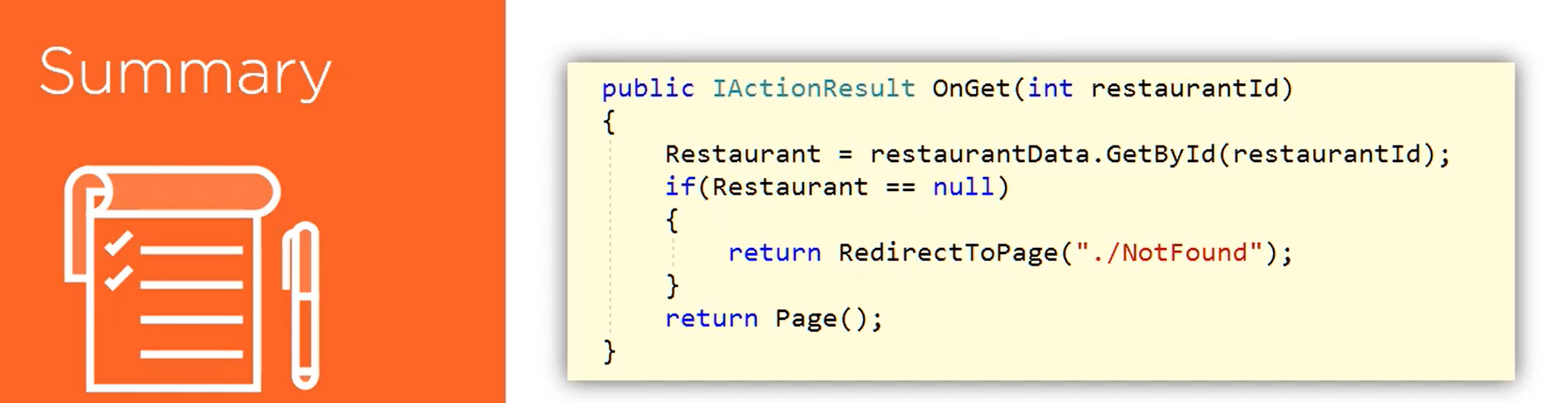

## Select list item

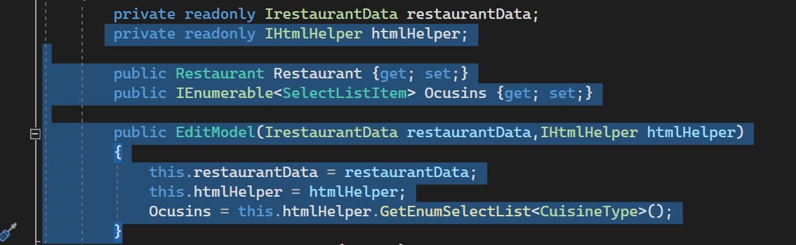

## Validation

Data annotation

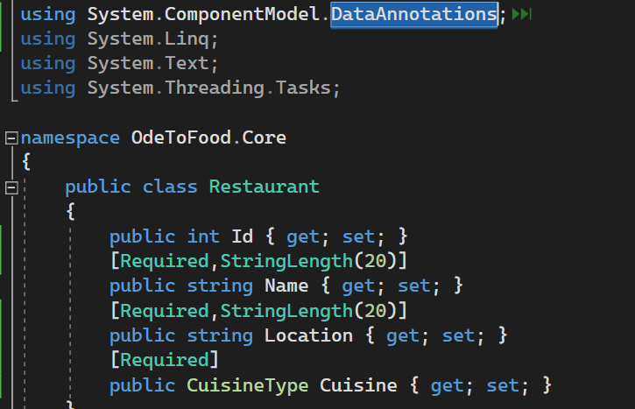

Modelstate

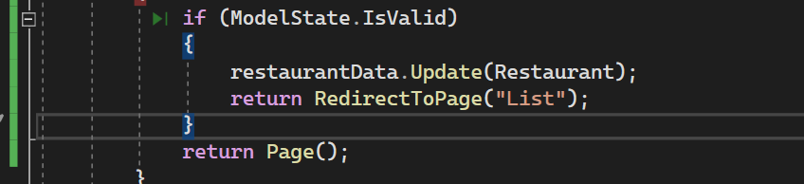

Asp Validation for

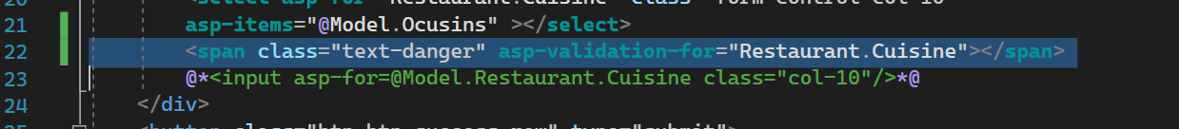

## Redirect to page with route value

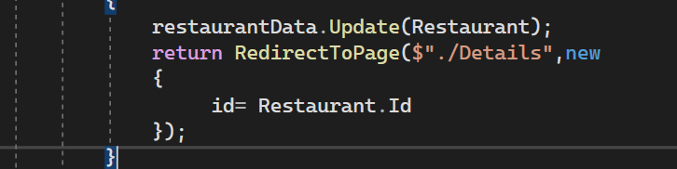

## Entity framework

Install package on project .data

1. Microsoft.EntityFrameworkCore

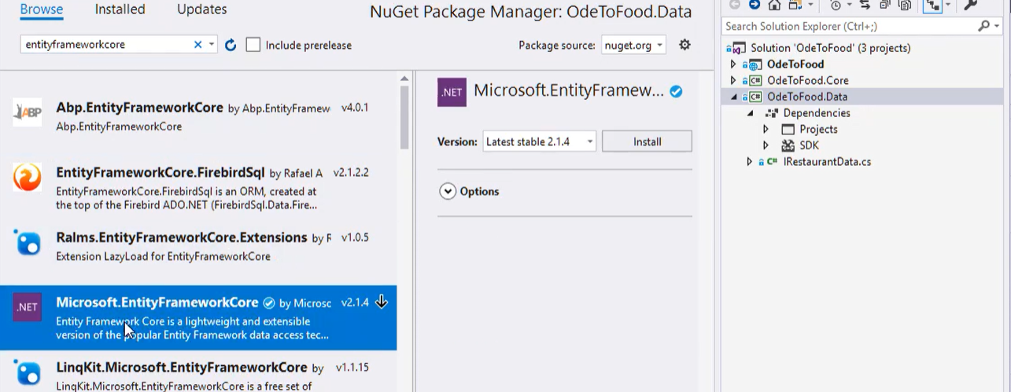

1. Microsoft.EntityFrameworkCore.Sqlserver

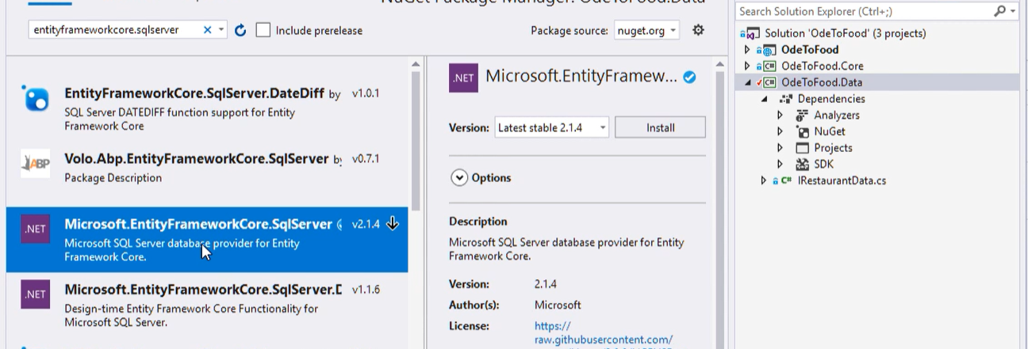

1. Microsoft.EntityFrameworkCore.Design

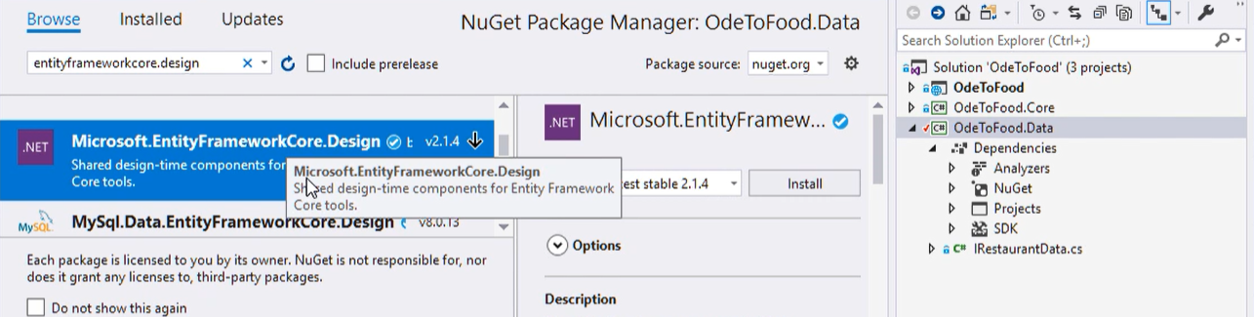

Add package design to startup project

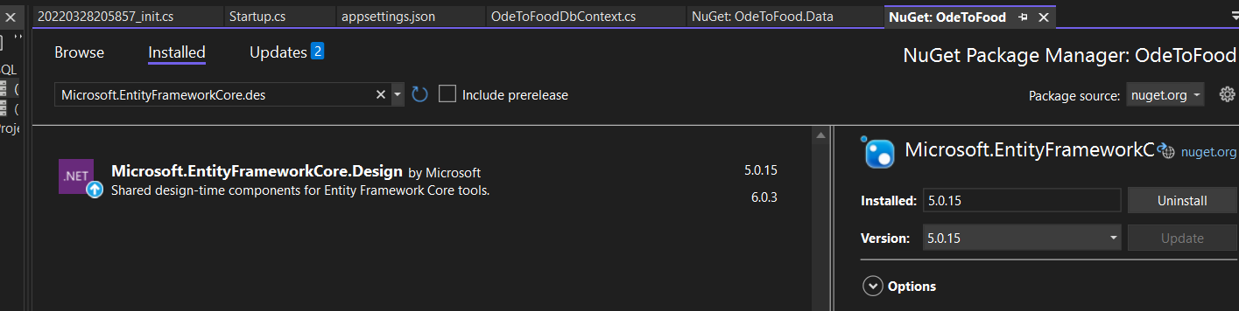

Create dbcontext class

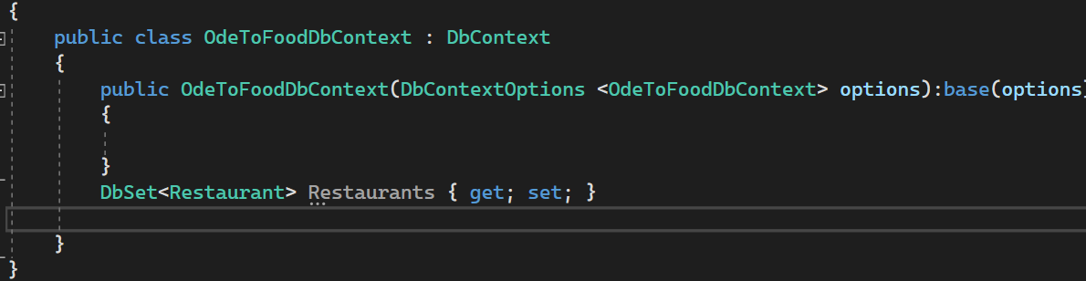

Add connection string on appsetting.json

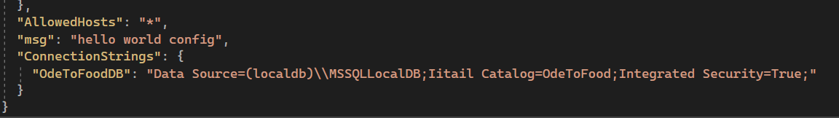

Add configure services

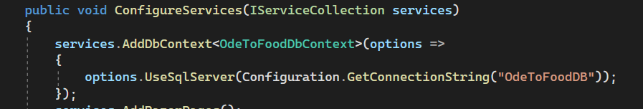

Open package manger console on odetofood.data

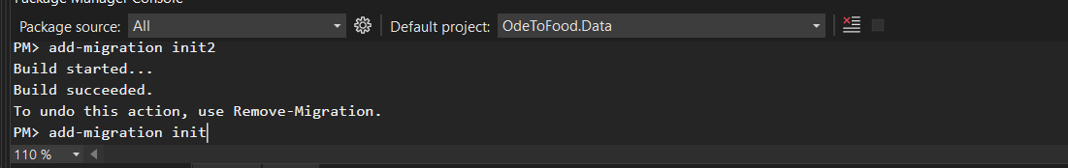

add-migration init

update-database

the migration

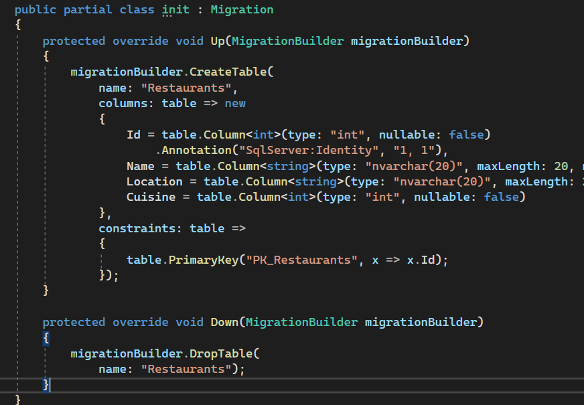

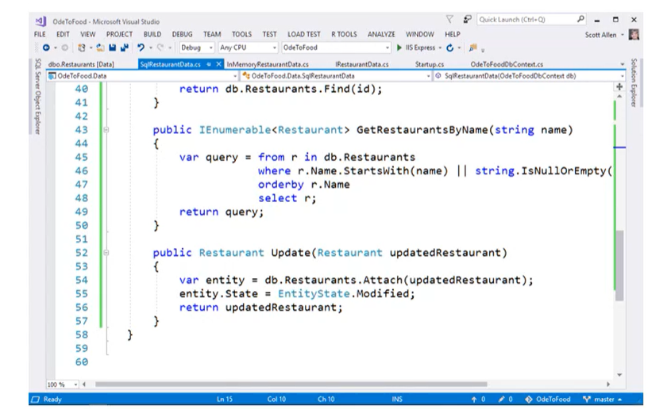

## Interface

@page directive

To make page a razor page

It makes the page response to url

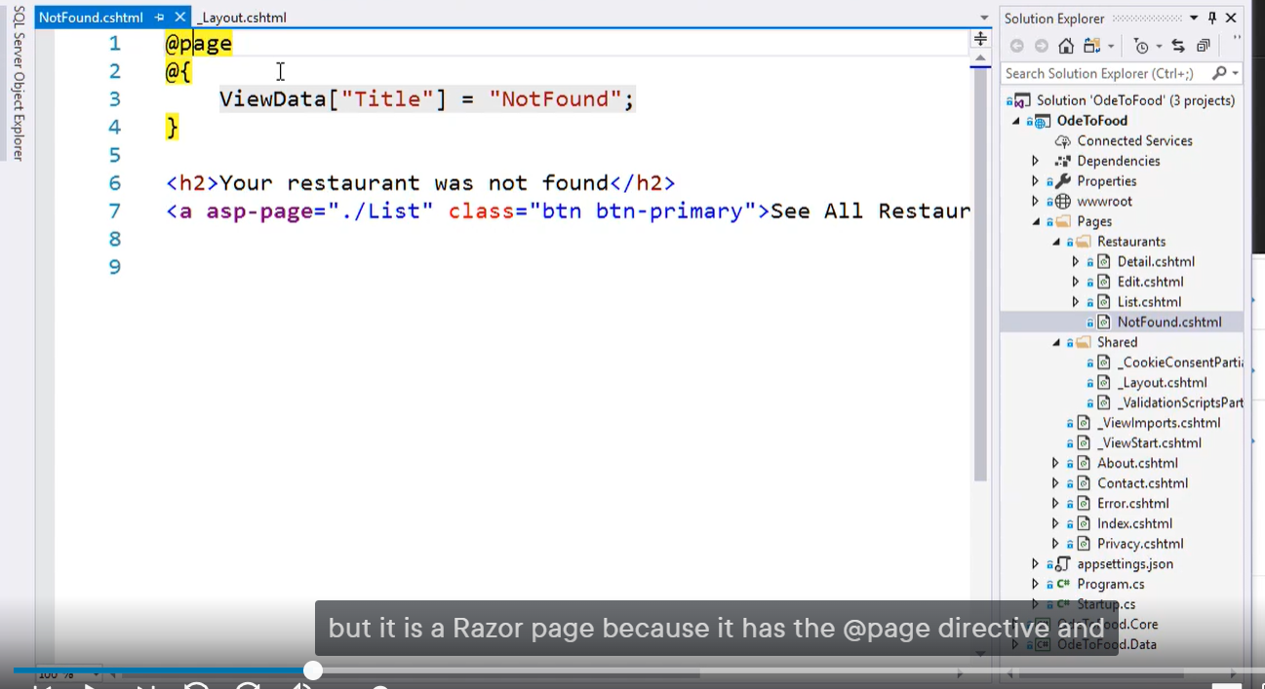

## _ViewStar

The page that execute before any razor page

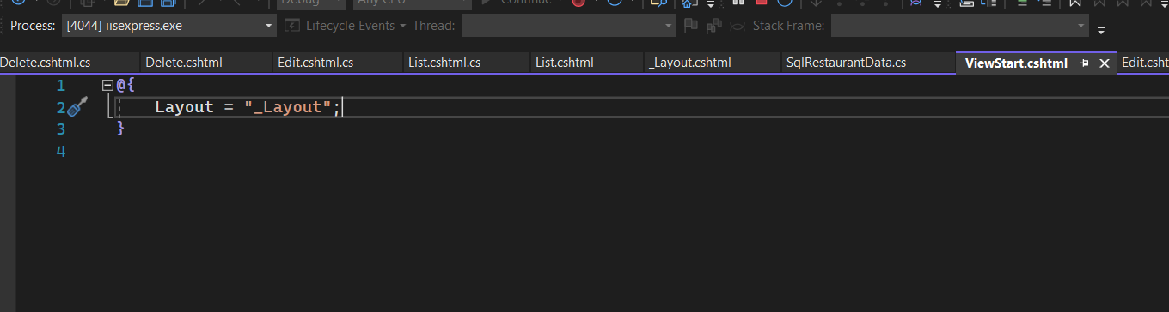

## _viewImport

To using namespaces

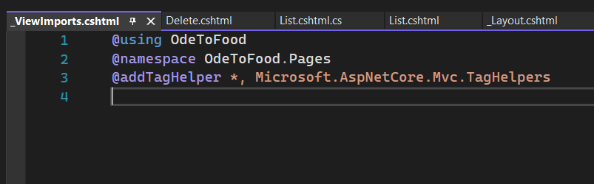

## View component

